# 2010: Choosing a Digital DJing Controller

<https://www.digitaldjtips.com/2010/06/choosing-a-digital-djing-controller/>

Here at Digital DJ Tips, our ethos is simple: DJing should be done digitally, and you should be able to fit all your DJ gear in a bag. That means a laptop, a controller, and anything else that will fit in the pockets and compartments of your DJ trolley, backpack or shoulder bag, such as headphones, soundcard etc.

Your controller is probably the most important choice you’ll make when it comes to DJ equipment, and it’s an intensely personal one. You can get by with any old laptop as long as it has the power to do what you need it to, but the controller is literally going to be in (or at least under) your hands all the time when you’re DJing.

Let me tell you about the controllers I’ve used through the years to illustrate…

Hercules MK1 – My first controller

[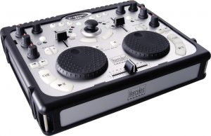](http://cdn.digitaldjtips.com/app/uploads/2010/06/09153329/mk1.jpg)The Hercules MK1 was one of the first digital DJ controllers to hit the streets.

Kudos to Hercules for being there at the start. I was working for IDJ magazine at the time (end of 2004) and they sent me this to review. To say it blew my mind was an understatement – to be able to control music like that was totally new to me. I was about to move countries, so personally the idea of not having to carry records around but still DJ was fantastic. Plus I’d never taken to CDJs.

I was DJing every Saturday night in a club at that time, and immediately started using the Hercules there, to many strange looks. It crashed a couple of times, but I always had some vinyl lined up “just in case”.

After a few weeks, though, it started to irk me. This was essentially a cheap, plastic unit; a lightweight, toy-like thing. The cueing was spongy. The unit was too small and I knocked the wrong controls when I was trying to do things. I was sent the MK2 by IDJ mag too, but same thing – it didn’t impress.

(Since then, I’ve used the Hercules RMX, just recently when my current controller was off for repair. It’s their top-end unit and while not professional quality, it’s very good for the price. Well done to Hercules for staying in the game.)

DJing with all kinds of kit

[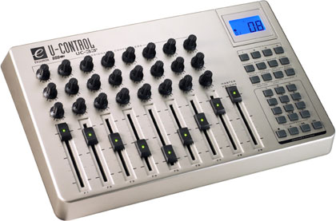](http://cdn.digitaldjtips.com/app/uploads/2010/06/09153329/EvolutionUC33.jpg)The Evolution UC3 is a great all-round controller, useful for Ableton as well as other DAWs and even DJing.

What happened next was curious, though: I was hooked on Virtual DJ, the software that came with the MK1. (I’d tried Traktor, but found it a bit gimmicky and not very user-friendly.) Virtual DJ, with its big waveforms and cute skins, was great fun to use. I was so hooked, in fact, that I bought the full-power version.

I still needed a controller though, so I tried DJing with an Evolution UC-33e I had knocking around, and even an M-Audio O2 controller. (Cue more weird looks from the clubbers. DJing with a piano keyboard?) Nothing did it for me, though.

Who needs a controller anyway?  
What I ended up doing was realising I didn’t need any extra kit apart from my laptop at all. I spent a day programming Virtual DJ to work with my keyboard using custom shortcuts, mirror-imaging the computer keyboard down the middle to give myself a left and right deck set of bass, mid, treble, kills, nudges, skips and sync controls. I put samples along the function keys and anything else I could think of, including a crossfader, on the other keys. From then, I DJed in the club with just the laptop. I bought an Indigo DJ soundcard that plugged into the VCI slot of the laptop, so literally I just had to take the laptop and some headphones to gigs with me. (Cue more very weird looks in the clubbers.)

[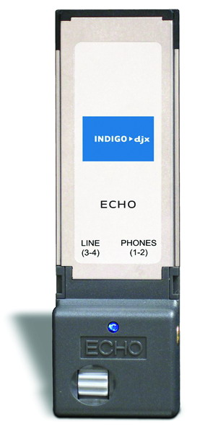](http://cdn.digitaldjtips.com/app/uploads/2010/06/09153328/indigo-djx.jpg)The Indigo Echo DJX soundcard is great for sheer convenience and the sound quality is top of the tops. It’s not cheap, though.

This set-up actually served me well for five years, DJing on and off in bars, parties and the odd club (I’d moved to Spain by then and was busy doing other stuff too). I loved Virtual DJ, and it was easy to set this up on any laptop, as long as I kept the XML for the keyboard shortcuts handy (I lost it once and had to program the whole lot again from scratch). My laptop WAS my DJ controller. As I am not a scratch DJ and don’t often scratch (maybe with acapellas a bit), it didn’t bother me to much.

Meanwhile, I kept an eye on the developing controller market, but nothing grabbed me enough to dip in again.

The seven year Itch  
(Well, six years actually, but I couldn’t resist the subheading.) When I decided to DJ a bit more often again, I wanted to get the tactile “fun” back into it, and so I started looking for a high-quality controller. I was being paid for my gigs, so I could justify spending what it took (which meant a new MacBook Pro, too. Hard life…). Once I had the MacBook, I wanted a controller/software combination that “just worked”, and was drawn to Serato Itch. I had to think long and hard about abandoning Viurtal DJ, which I loved, but took the plunge and went for the Serato Itch / Vestax VCI-300 combo.

(I’d had my eye on the VCI-100 and played with it enough to know it was the real deal, but meanwhile had fallen for Itch, so my controller choice was limited, especially as the fantastic Numark NS7 was far too big to carry around on my shoulder.)

The VCI-300, apart from being well built and having well-spaced controls, is simple, simple, simple. The jogwheels are a complete joy, the touch sensitivity means scratching is easy, and the way the jogwheels have two functions depending on whether you touch their edge (like a record edge) or their top (like a record’s surface) is fiendishly clever and not repeated by any other manufacturer that I know of.

You forget you’re using it and enjoy the music, the selections, the night, the people – everything you should be enjoying as a good DJ. It feels almost TOO simple, and indeed on-board FX control would have been nice, but it’s a 9/10 for me. And that brings us up to date…

The next two years will be really interesting…

[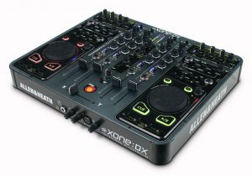](http://cdn.digitaldjtips.com/app/uploads/2010/06/09153328/xonedx.jpg)The Allen & Heath Xone DX has it all – except best-in-class jogwheels

My point is that digital DJing lives or dies by the quality of its controllers. DJing with just the keyboard is clever and convenient, but DJing is a lot about playing with controls at the end of the day.

Forget the big, cumbersome CDJ-2000s and that route. Yeah they’re standard in superclubs and the old boys love ’em, but it’s still shoehorning new technology into old. You don’t need that stuff any more. And while we’re at it, virtual vinyl is great if you already have decks or are a diehard scratch DJ (yawn), but really, would you go and buy decks then a DVS? They don’t even MAKE Technics any more, for Pete’s sake. There are iPod DJ controllers (see first pic) too which have a certain appeal, but it’s nice to have a proper display.

No, the way forward is proper laptop-driven DJ controllers. Vestax already have lots of spin-offs (sorry for the pun) of the VCI-100 and VCI-300, no doubt with more to come. Allen & Heath’s DX is interesting for the 4-deck technicians who want to have a a few tricks up his or her sleeve – although that jogwheel looks like an afterthough to me. There are loads of quality controllers coming out, but the point is, there’s no industry standard yet, and that’s exciting. The reason is that while the popularity of digital DJing will certainly mushroom when everyone unites behind one standard set of features (if not one standard manufacturer), in the meantime – who knows what will happen next?

[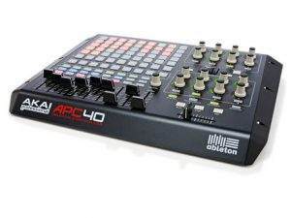](http://cdn.digitaldjtips.com/app/uploads/2010/06/09153328/apc40.jpg)How much fun could DJing be with the Akai APC40 and Ableton? Watch this space…

Another very interesting development, is DJing with digital audio workstations (DAWs), led by Ableton, which itself has got some very tasty controllers. This changes the very nature of DJing in that all of the beatmatching and “vinyl” control is gone. I am planning to invest some time in this area and am looking at the Akai and Novation controllers to see what these can bring to my performances, so watch this space on that one.

So – which controller to use?  
So, what has all of this spending and experimenting led me to conclude, kit-wise? Well, I can only recommend what I’ve used, and so my current recommendations to new DJs go like this:

If you don’t have much cash, get the Hercules RMX, which comes with a version of Virtual DJ and has a built-in soundcard. It’s a well-built, solid unit which, while lacking the finesse of the VCIs, will last you a long time and won’t make you look stupid in pubic (obviously an important thing.) Don’t buy anything cheaper. It will probably break. You’ll definitely end up hating it.

If you have a bit more to spend, especially if you want to play with scratching digital files, go for a Vestax. Go for the VCI-100 if you think Traktor will be the DJ software for you (although you’ll need a soundcard, and here I still recommend the Indigo series for sheer convenience), and go for the VCI-300 if you think Serato Itch will be better.

(Regarding the software, Itch is the one for you if you prefer to just “let the music play”, Traktor has got more tricks up its sleeve but sacrifices ease of use.)

Whichever option you go for, try and look at and play on the kit first. Like your bed or your shoes, a DJ controller badly chosen will cause you no end of strife. Pick carefully, and come on inside. It’s a lot of fun over here on the right side of the digital divide!

Are you looking for your first controller? Have you DJed on weird and wonderful Midi equipment over the years? Did you buy something you ended up wishing you hadn’t? We’d love you to share your thoughts.

# Single Jogwheel DJ Midi Interfaces: 5 Top Models Reviewed & Rated

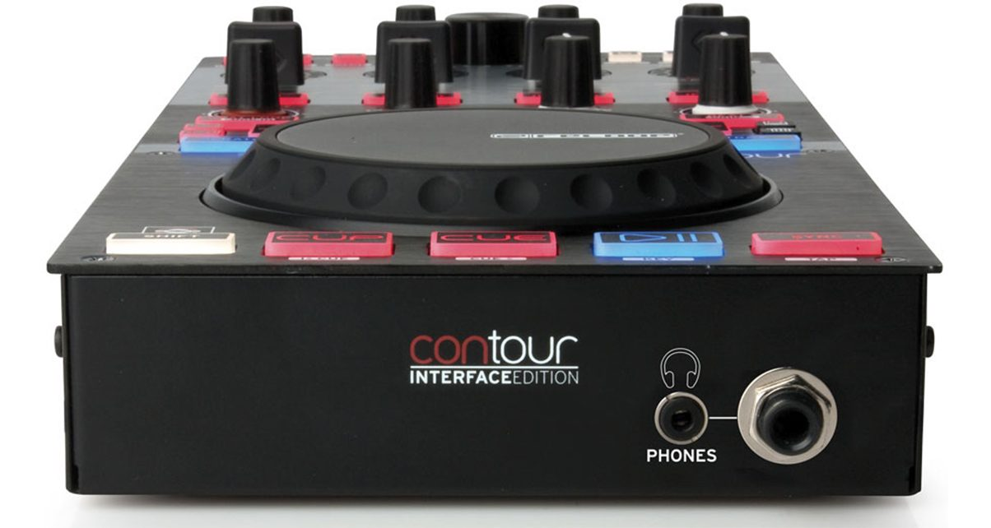



###### Phil Morse

December 17, 2010 | Read time: 6 mins

[Allen & Heath](https://www.digitaldjtips.com/tag/allen-heath) [EKS Otus Plus](https://www.digitaldjtips.com/tag/eks-otus-plus) [EKS XP5](https://www.digitaldjtips.com/tag/eks-xp5) [numark v7](https://www.digitaldjtips.com/tag/numark-v7) [reloop contour](https://www.digitaldjtips.com/tag/reloop-contour) [Xone:2D](https://www.digitaldjtips.com/tag/xone2d)

LAST UPDATED 5 MARCH, 2019

 7 Comments

 4168

## Review: 5 Top Models of Single Jogwheel DJ Midi Interfaces

A couple of weeks ago we looked at [single-jogwheel DJ Midi controllers](http://www.digitaldjtips.com/2010/12/single-jogwheel-dj-midi-controllers-review/). This week we’re going to look at single-jogwheel DJ interfaces. The wording can get confusing (as they’re quite often all referred to as controllers), but basically what we mean by this is DJ control devices with sound interfaces or sound cards built-in.

With these units, you plug them into your laptop to link them to the DJ software and plug the output from the unit into your powered speakers, a club PA, or more than likely an audio mixer. In a way, these units are closest to the traditional single-deck CDJ players like the Pioneer CDJ-1000, only instead of CDs, they have a laptop providing the music source – and you get to control up to 4 decks.

### Why you might want one (or two…)

All the reasons for our [single-jogwheel DJ Midi controller round-up](http://www.digitaldjtips.com/2010/12/single-jogwheel-dj-midi-controllers-review/) still hold true. The difference here is that with a built-in sound card, these units give you all-in-one digital functionality without the need for an external card. So why would that appeal to the DJ?

[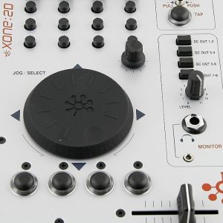](http://cdn.digitaldjtips.com/app/uploads/2010/12/09152835/xone-2d_silver.jpg)A single jogwheel DJ interface can provide much of the functionality of an all-in-one DJ controller, letting you integrate digital DJing into an existing set-up easily.

* Convenience – If you don’t want to mess around with an external sound card, and don’t have a digital/USB mixer with a sound cards built in, one of these may make more sense in your set-up. Or, you may want to keep your existing analogue mixer and just plug one of these into spare channel/s in order to add digital. Thus a[digital controller with a built-in mixer](http://www.digitaldjtips.com/2010/11/dj-midi-controllers-buyers-guide-2011/) wouldn’t make sense
* Availability – There are some lovely units here. If you’ve got your heard set on the aesthetics and functionality of the Numark V7 or the EKS Otus, for instance, then you can’t even get these in pure Midi controller versions
* Digital DJing from one unit – Controlling 2 decks from a small, slim interface with a built-in jogwheel (a couple of these units are pretty small) and built-in sound card means that you can add multi-deck digital functionality with the purchase of just one small unit (and a laptop of course). If you’ve ever looked at all-in-one DJ controllers and thought “but I only need one platter”, these are your choices – especially the Allen & Heath model with a crossfader

Please remember that while we try our hardest to get all the facts straight, we are not guaranteeing the suitability of any of these units for your particular hardware/software combination. Most can be mapped to any software, but it often takes effort.

As always, we’d advise reading up carefully on them and doing your research before buying one. It’s part of the fun, after all! Happy hunting.

### The controllers

[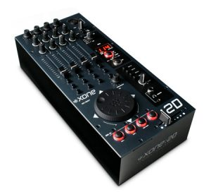](http://cdn.digitaldjtips.com/app/uploads/2010/12/09152835/xone-2d.jpg)Solidly built with a definite utilitarian feel, the Allen & Heath Xone:2D screams professionalism.

#### Allen & Heath Xone:2D

Price: [US$699](http://www.amazon.com/gp/product/B001FY39O4?ie=UTF8&tag=pbmo-20&linkCode=as2&camp=1789&creative=390957&creativeASIN=B001FY39O4) / [£658](http://www.amazon.co.uk/gp/product/B003129DI4?ie=UTF8&tag=didjti-21&linkCode=as2&camp=1634&creative=19450&creativeASIN=B003129DI4) / [€679](http://www.thomann.de/index.html?partner_id=39004&page=gb/allenheath_xone2d_black.htm)  
Rating: [rating=4]

Decks controllable: 2 (out of the box), 4 possible; High-resolution jogwheel: yes; Software compatibility: Traktor, Ableton; Stereo audio outputs: 4 analogue, 1 digital (SPDIF/optical); Audio inputs: 3 analogue (2 switchable line/phono), 1 digital; Power: Mains; Sound card specifications: 96kHz/24 bit; Other: earth pole, Midi in/out; Size & weight: 6.3 x 3.5 x 14″ (160 x 88 x 358mm), 4.4lb (2kg)

They say: The Xone:2D is a combination of a 9 stereo channel USB 2.0 soundcard and Midi controller, which DJs can combine with their existing analogue mixer to create a complete Digital DJ mixing system, perfect for integration with DJ software such as Ableton Live and Traktor DJ Studio.

We say: In a class of its own here for build quality, flexibility (it has a crossfader, for instance) and features. Visual BPM counter and Midi clock. Headphones monitoring with two sizes (1/8″ and 1/4″) is a nice touch. On the large side of portable. Lacking the visual features of the newer controller.

See it at: [Amazon.com](http://www.amazon.com/gp/product/B001FY39O4?ie=UTF8&tag=pbmo-20&linkCode=as2&camp=1789&creative=390957&creativeASIN=B001FY39O4), [Amazon.co.uk](http://www.amazon.co.uk/gp/product/B003129DI4?ie=UTF8&tag=didjti-21&linkCode=as2&camp=1634&creative=19450&creativeASIN=B003129DI4), [Thomann (UK & rest of Europe)](http://www.thomann.de/index.html?partner_id=39004&page=gb/allenheath_xone2d_black.htm)

[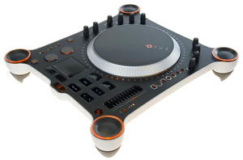](http://cdn.digitaldjtips.com/app/uploads/2010/12/09152834/eks-otus-plus1.jpg)the EKS Otus Pus has the same footprint as a standard turntable and packs stunning looks.

#### EKS Otus Plus

Price: [US$749](http://www.amazon.com/gp/product/B001O3QN94?ie=UTF8&tag=pbmo-20&linkCode=as2&camp=1789&creative=390957&creativeASIN=B001O3QN94) / [£449](http://www.amazon.co.uk/gp/product/B001O3QN94?ie=UTF8&tag=didjti-21&linkCode=as2&camp=1634&creative=19450&creativeASIN=B001O3QN94) / [€528](http://www.juno.co.uk/products/eks-otus-matte-usb-midi-digital-dj-controller-deck-with-audio-output/389512-01/?ref=ddjt)

Rating: [rating=3]

Decks controllable: 2; High-resolution jogwheel: yes; Software compatibility: Traktor, Deckadance, MixVibes; Stereo audio outputs: 2; Audio inputs: none; Power: USB/mains; Sound card specifications: 44.1kHz/24 bit; Other: 2 SPDIF outs; Size & weight: 14.3 x 14.3 x 2.8in (365 x 335 x 70mm), 4.4lb (2kg)

They say: Otus Plus is the new revision of our award-winning Otus Dualdeck DJ Controller with improvements in many areas. The stylish physical appearance and clever design combined with a solid build will make any professional DJ feel at home with Otus+ from the very first encounter.

We say: Gorgeous design but obviously, you’ll need a bigger bag than some to carry it around ([UDG](http://www.amazon.com/gp/product/B00466HR1E?ie=UTF8&tag=pbmo-20&linkCode=as2&camp=1789&creative=390957&creativeASIN=B00466HR1E) do a custom one). Easy dual deck capability with red/green backlighting making things clear. Lovely touch-sensitive jogwheel. Trackpad built in means you can leave your laptop alone. Specify the Plus model before ordering – it replaces the previous model. Also, look out for Otus RAW (not available yet). Good controller but very expensive.

See it at: [Amazon.com](http://www.amazon.com/gp/product/B001O3QN94?ie=UTF8&tag=pbmo-20&linkCode=as2&camp=1789&creative=390957&creativeASIN=B001O3QN94), [Amazon.co.uk](http://www.amazon.co.uk/gp/product/B001O3QN94?ie=UTF8&tag=didjti-21&linkCode=as2&camp=1634&creative=19450&creativeASIN=B001O3QN94), [Juno (UK & rest of Europe)](http://www.juno.co.uk/products/eks-otus-matte-usb-midi-digital-dj-controller-deck-with-audio-output/389512-01/?ref=ddjt)

[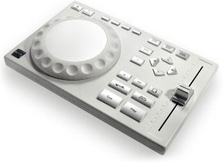](http://cdn.digitaldjtips.com/app/uploads/2010/12/09152833/eks-xp5.jpg)Good looking and compact, the EKS XP5 is nonetheless a bit long in the tooth nowadays.

#### EKS XP-5

Price: [US$169](http://www.amazon.com/gp/product/B0015U7KUW?ie=UTF8&tag=pbmo-20&linkCode=as2&camp=1789&creative=390957&creativeASIN=B0015U7KUW) / [£119](http://www.thomann.de/index.html?partner_id=39004&page=gb/eks_xp5.htm) / [€141](http://www.thomann.de/index.html?partner_id=39004&page=gb/eks_xp5.htm)  
Rating: [rating=2]

Decks controllable: 1; High-resolution jogwheel: no; Software compatibility: Traktor LE; Stereo audio outputs: 2; Audio inputs: 0; Power: USB; Sound card specifications: n/a; Size & weight: 5.5 x 8.3 x 1″ (140 x 210 x 25mm), 0.8lb (370g)

They say: XP-5 is a lightweight plug-and-play controller – a portable solution for a serious digital age DJ looking for top-notch sound and professional level features at an affordable price. It allows the user to choose a mixer of their preference, but can also be configured to work as an all in one control device.

We say: Quality sound card but expensive for what it is and outdated thanks to newer models with more features on the market. Jogwheel is touch-sensitive but bettered by newer models. No headphones socket. Was a player in its day but hard to recommend now at this price point.

See it at: [Amazon.com](http://www.amazon.com/gp/product/B0015U7KUW?ie=UTF8&tag=pbmo-20&linkCode=as2&camp=1789&creative=390957&creativeASIN=B0015U7KUW), [Thomann (UK & rest of Europe)](http://www.thomann.de/index.html?partner_id=39004&page=gb/eks_xp5.htm)

[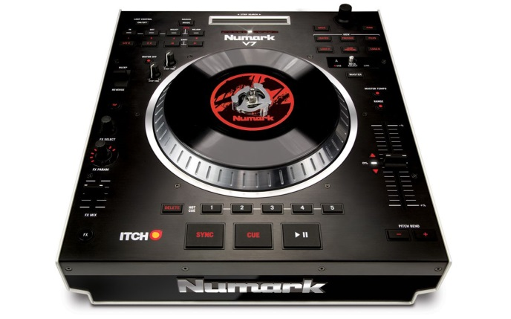](http://cdn.digitaldjtips.com/app/uploads/2010/09/09153146/numark-v7-review.jpg)The Numark V7: Is this the Technics 1210 of the digital DJ world?

#### Numark V7

Price: [US$432](http://www.amazon.com/gp/product/B0038YX38Q?ie=UTF8&tag=pbmo-20&linkCode=as2&camp=1789&creative=390957&creativeASIN=B0038YX38Q) / [£489](http://www.amazon.co.uk/gp/product/B0038YX38Q?ie=UTF8&tag=didjti-21&linkCode=as2&camp=1634&creative=19450&creativeASIN=B0038YX38Q) / [€611](http://www.thomann.de/index.html?partner_id=39004&page=gb/numark_v_7.htm)

Rating: [rating=4]

Decks controllable: 2; High-resolution jogwheel: yes; Software compatibility: Serato ITCH; Stereo audio outputs: 2; Audio inputs: 0; Power: Mains; Sound card specifications: 24-bit/44.1kHz; Size & weight: 12.6 x 14.5 x 4.4″ (320 x 368 x 112mm), 16.4lb (7.5kg)  
16.4 lbs.

They say: based around the acclaimed adjustable torque, a motorized-platter design from Numark’s NS7 and delivers a host of professional features including real vinyl and a slipmat that analogue turntablists will love, plus turntable control at 10 times the resolution of standard MIDI, mouse-less library navigation, and Strip Search virtual-needle drop.

We say: Closes to using a Technics turntable you’ll get for digital. Feels like real DJing, and the strip search is a clever track scrubbing addition. Combined with the supplied Serato ITCH software, this is a brilliant way of adding 2 real digital decks to an existing set-up. Two of these can’t control 4 decks in Serato ITCH though, which is a big shame.

See it at: [Amazon.com](http://www.amazon.com/gp/product/B0038YX38Q?ie=UTF8&tag=pbmo-20&linkCode=as2&camp=1789&creative=390957&creativeASIN=B0038YX38Q), [Amazon.co.uk](http://www.amazon.co.uk/gp/product/B0038YX38Q?ie=UTF8&tag=didjti-21&linkCode=as2&camp=1634&creative=19450&creativeASIN=B0038YX38Q), [Thomann (UK & rest of Europe)](http://www.thomann.de/index.html?partner_id=39004&page=gb/numark_v_7.htm)

[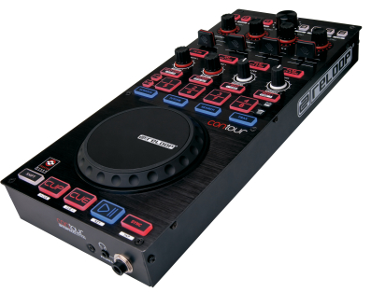](http://cdn.digitaldjtips.com/app/uploads/2010/12/09152833/relpp-contour-interface-edition.png)The Reloop Contour Interface Edition is bang up to date on the features-front, with clever handling of 4 decks.

#### Reloop Contour Interface Edition

Price: [£299](http://www.dolphinmusic.co.uk/product/53087-reloop-contour-interface-edition-.html?locale=en_GB) / [€351](http://www.dolphinmusic.co.uk/product/53087-reloop-contour-interface-edition-.html?locale=de_DE)  
Rating: [rating=4]

Decks controllable: 4; High-resolution jogwheel: yes; Software compatibility: Traktor Pro; Stereo audio outputs: 4; Audio inputs: 0; Power: USB/mains; Sound card specifications: 24-bit/96kHz; Size & weight: 6.3 x 15.1 x 2.5″ (160 x 383 x 63mm), 4.4lb (2kg)

They say: Can be perfectly integrated in every DJ software surroundings. Configured and optimized for Traktor Pro, it is possible to control up to 4 decks, due to the intelligent deck switch system. Specially developed for DJs that wish to integrate Traktor in their existing setup.

We say: Direct appeal to people eyeing the X1 controller for Traktor Pro. With this you get full 4-deck control, a jogwheel, 4-stereo-outs sound card built-in, 1(8 & 1/4″ headphone outputs (nice touch), a lot of configurability, and a decent build quality including nice aluminium fascia. Hard to find at moment in the US.

See it at: [Dolphin Music (UK)](http://www.dolphinmusic.co.uk/product/53087-reloop-contour-interface-edition-.html?locale=en_GB), [Dolphin Music (rest of Europe)](http://www.dolphinmusic.co.uk/product/53087-reloop-contour-interface-edition-.html?locale=de_DE)

### Conclusion

A varied bunch here that should be considered alongside their [sound card-less brothers](http://www.digitaldjtips.com/2010/12/single-jogwheel-dj-midi-controllers-review/). No straight 5s here as all have their benefits and drawbacks.

It’s hard to recommend the EKS product, as the XP-5 is old and the Otus is a boutique product only for people with a lot of money to spend. (If you have, though, and you really want this controller, it’s a great product.)

The Allen & Heath is perfect if you know what you’re doing and you’re sure it’s what you want – for some, this will be the only choice here. It’s certainly got the most flexibility. But controlling 4 decks on it with no good visual indicator is going to be hairier than the Reloop Contour, for instance.

The Reloop Contour is, on the face of it, a class act – but as we haven’t heard its sound card as it is only due in the shops about now, we’d like some feedback as to the quality of that sound before giving a definitive recommendation. Give it a good listen before buying or make sure you can return it if you decide you want to.

If you’re a Serato ITCH user, the V7 should have you salivating – it’s the only controller here with a motorised platter. Shame two of them can’t control the 4-deck version of ITCH, though, like the Allen & Heath Xone:DX can, as it’s hard to see DJs shelling out this kind of cash and not wanting that functionality.

## Review: 6 Top Single Jogwheel DJ Midi Controllers

Modern DJ Midi controllers tend to be all-in-one units, with 2 “decks” and a mixer in the one box. But, of course, traditional DJ set-ups are separates – typically 2 decks for vinyl or CD, and a separate mixer. And while all-in-one units have revolutionised DJing, there’s still a demand for separate, modular digital DJ kit.

Single jogwheel DJ Midi controllers allow the laptop DJ to reintroduce elements of the traditional DJ set-up for whatever reason. Here we look at 6 single-jogwheel DJ midi controllers. (By the way, we’re calling them “single jogwheel” rather than “single deck” throughout this review for the sake of clarity, because many can actually control 2 or more decks for you.)

### Why you might want one

With the ability to control digital audio like a real CDJ or turntable (hi-resolution jogwheels make scratching sound convincing, for instance), plus added buttons and faders for effects, loops, deck switching and so on, these units give you a lot of punch. You may want to add one of these to your setup for a number of reasons:

1. **Because you want to DJ the traditional “way” but with 100% digital equipment** – whether because you want the layout to be more spread out, or because you just prefer to mix and match brands in your digital set-up
2. **Because you already own equipment you want to keep** – If you have a great mixer, why not add a couple of digital decks and a sound card, and keep it? If you’re used to a high-end Pioneer or Allen & Heath mixer, you’re not going to get the same features from an all-in-one DJ controller
3. **Because you want to add digital to an existing analogue set-up** – If you just want to add one or two channels of digital into your vinyl/CD DJ set-up, this is the way to go
4. **Because you want to use a powerful, modern digital DJ mixer** – Some of the newest mixers like the [Allen & Heath Xone:DB4](http://www.digitaldjtips.com/2010/09/xone-db4-review/) do things controllers just can’t. You can now assemble an awesome digital system with single jogwheel controllers and a new digital mixer at its heart
5. **Because you just want to add some deck control to your laptop DJ set-up** – You can[DJ perfectly well on just a laptop](http://www.digitaldjtips.com/2010/11/coming-soon-how-to-dj-properly-with-just-a-laptop/). If you DJ from your netbook and don’t want to buy any bulky equipment at all, yet crave some real jogwheel action and a few useful extra buttons and knobs, adding a tiny, portable single jogwheel DJ midi controller could give you everything you need but still let you throw it all in a side-pocket of your backpack. Have party, will travel…
6. **Because one deck is all you need** – If your style of DJing uses effects, Ableton, looping and pad triggers as DJ tools, having TWO jogwheels may be overkill – maybe you’d rather have one unit with a jogwheel, and another unit doing something else entirely…
7. **Because you want to control 4 decks in Traktor** – If you have a VCI-100 (or other 2-deck controllers), you may be quite happy with it but still want to unlock one or both of the other 2 decks in Traktor Pro. With one of these, you can.

### Do I need a sound card with one of these?

Yes. We’ve gone only for controllers, not interfaces – ie, these have no built-in sound cards. That’s just because we feel most people interested in this type of controller will either already have a sound card, or be looking at an external card or a DJ mixer with one built in – or even (in the case of using one to add some control over just one channel of laptop music in an existing setup) not using a sound card at all and relying on their laptop’s sound output. However, we will be covering such units with built-in sound cards at a later date.

**Finally…**  
Please remember that while we try our hardest to get all the facts straight, we are not guaranteeing the suitability of any of these units for your particular hardware/software combination. Most can be mapped to any software, but it often takes effort.

As always, we’d advise reading up carefully on them and doing your research before buying one. It’s part of the fun, after all! Happy hunting.

### The controllers

[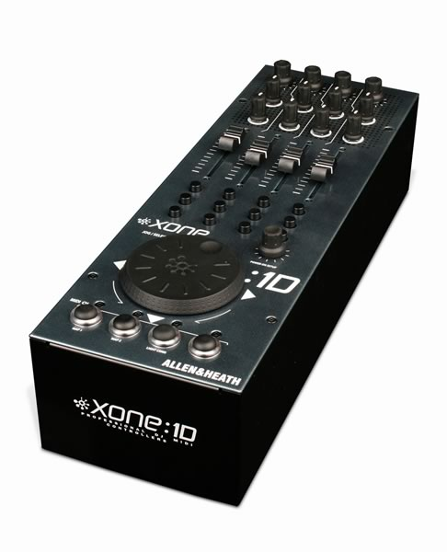](http://cdn.digitaldjtips.com/app/uploads/2010/12/09152858/Xone-1d.jpg)The Allen & Heath Xone:1d doesn\’t do as much as some of these, but what it does, it does brilliantly.

#### Allen & Heath Xone:1D

Price: [US$319](http://www.amazon.com/gp/product/B0016MNG1Q?ie=UTF8&tag=pbmo-20&linkCode=as2&camp=1789&creative=390957&creativeASIN=B0016MNG1Q) / [£177](http://www.thomann.de/index.html?partner_id=39004&page=gb/allenheath_xone1d.htm) / [€209](http://www.thomann.de/index.html?partner_id=39004&page=gb/allenheath_xone1d.htm)  
Rating: [rating=4]

Decks controllable: 1*; High-resolution jogwheel: yes; Software compatibility: Traktor, Ableton Live; Size & weight: 3.5 x 14 x 4.7″ (88 x 358 x 120mm), 4lb (1.8kg) *Multi-deck control Midi mappable

They say: The Xone:1D is a dedicated Midi controller connected and powered by USB. Use the Xone:1D with any DJ mixer to add digital control, or add the 1D to a Xone:2D to your favourite mixer to make up the equivalent to a Xone:3D. All the Midi controls can be mapped to software for use as navigation controls.

We say: Highly professional gear, better for permanent than portable use. Not the best for multi-deck control as no standout visual indicator of deck alignment. If you want a truly pro, installation equipment (and don’t mind jogs that aren’t up to scratching), this is it. Even has 5-pin DIN Midi sockets for connection to other Midi devices. Top quality.

See it at: [Amazon.com](http://www.amazon.com/gp/product/B0016MNG1Q?ie=UTF8&tag=pbmo-20&linkCode=as2&camp=1789&creative=390957&creativeASIN=B0016MNG1Q), [Thomann (UK & rest of Europe)](http://www.thomann.de/index.html?partner_id=39004&page=gb/allenheath_xone1d.htm)

[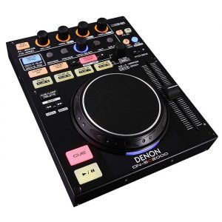](http://cdn.digitaldjtips.com/app/uploads/2010/10/09153038/denon-dn-sc-2000.jpg)Styled in the typical Denon way, the DN-SC2000 is colourful yet professional looking.

#### Denon DN-SC2000

Price: [US$249](http://www.kqzyfj.com/click-3957275-10449560?url=http%3A%2F%2Fwww.guitarcenter.com%2FDenon-DN-SC2000-Compact-2-Deck-USB-MIDI-Controller-H68106-i1629689.gc&cjsku=H68106) / [£159](http://www.thomann.de/index.html?partner_id=39004&page=gb/denon_dnsc2000.htm) / [€188](http://www.thomann.de/index.html?partner_id=39004&page=gb/denon_dnsc2000.htm)  
Rating: [rating=5]

Decks controllable: 2; High-resolution jogwheel: yes; Software compatibility: Traktor Pro, Virtual DJ; Size & weight: 6.7 x 1.2 x 8.6″ (170 x 30 x 218 mm), 2.9lb (1.3kg)

They say: The unit is an affordable, compact, professional-grade, solid steel Midi controller designed for the home DJ or party laptop DJ on the go. A 2-layer system, the unit can control 2 decks at once (with visible deck colour change), or be paired with another DN-SC2000 unit to control 4 decks.

We say: It’s tiny, thin, well built, and screams “professional”. The long-throw fader for pitch is as good as any analogue equipment, and the way the backlighting works is good both in clubs and when using two decks with the one unit.

See it at: [Guitar Center (US)](http://www.kqzyfj.com/click-3957275-10449560?url=http%3A%2F%2Fwww.guitarcenter.com%2FDenon-DN-SC2000-Compact-2-Deck-USB-MIDI-Controller-H68106-i1629689.gc&cjsku=H68106), [Thomann (UK & rest of Europe)](http://www.thomann.de/index.html?partner_id=39004&page=gb/denon_dnsc2000.htm)

[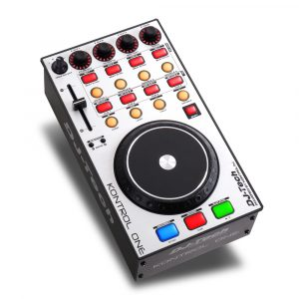](http://cdn.digitaldjtips.com/app/uploads/2010/12/09152900/dj-tech-kontrol-one.jpg)With a look of the Faderfox range about it, the DJ Tech Kontrol One offers a lot of Midi features.

#### DJ Tech Kontrol One

Price: [US$199](http://www.amazon.com/gp/product/B003MQFN6A?ie=UTF8&tag=pbmo-20&linkCode=as2&camp=1789&creative=390957&creativeASIN=B003MQFN6A) / [£119](http://www.thomann.de/index.html?partner_id=39004&page=gb/dj_tech_kontrol_one.htm) / [€141](http://www.thomann.de/index.html?partner_id=39004&page=gb/dj_tech_kontrol_one.htm)  
Rating: [rating=3]

Decks controllable: 4; Software compatibility: Traktor Pro, Deckadance; High-resolution jogwheel: yes; Size & weight: n/a

They say: The Kontrol One is a professional DJ Midi controller designed specifically to enjoy the functionality of the most advanced DJ pro software in the world. Kontrol One will satisfy the needs of the DJs who still want the tactile experience of DJing, with digital media in computer-based systems.

We say: Not to be confused with the Native Instruments Kontrol X1. This unit is well built and has a good, touch-sensitive jogwheel. It has the ability to control 4 decks so in theory, you could add this to your laptop and rock 4 decks on Traktor Pro. Great value, but the company website and support materials are ropey.

See it at: [Amazon.com](http://www.amazon.com/gp/product/B003MQFN6A?ie=UTF8&tag=pbmo-20&linkCode=as2&camp=1789&creative=390957&creativeASIN=B003MQFN6A), [Thomann (UK & rest of Europe)](http://www.thomann.de/index.html?partner_id=39004&page=gb/dj_tech_kontrol_one.htm)

[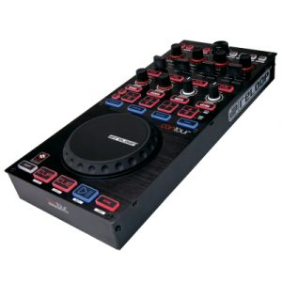](http://cdn.digitaldjtips.com/app/uploads/2010/12/09152900/reloop-contour-controller-edition.jpg)The Reloop Contour Controller Edition packs a lot of features into its sleek metal case.

#### Reloop Contour Controller Edition

Price: [£219](http://www.dolphinmusic.co.uk/product/53087-reloop-contour-controller-edition-.html) / [€260](http://www.dolphinmusic.co.uk/product/53087-reloop-contour-controller-edition-.html?locale=de_DE)  
Rating: [rating=4]

Decks controllable: 4; High-resolution jogwheel: yes; Software compatibility: Traktor Pro; Size & weight: 6.3 x 2.5 x 15.1″ (160 x 63 x 383mm) Weight: 4.4lb (2kg)

They say: Control up to 4 decks, due to the intelligent deck switch system. The large, backlit buttons shed light on the current status. Sections for deck, sample, and loop control are ready on stand-by. The extensive effect section disposes of 4 feedback encoders, 4 mini faders and further 4 rubberised buttons.

We say: The touch-sensitive jog wheel is big and feels good. The unit is well built, and if you like the styling and features of the Digital Jockey range you’ll feel at home here as that’s what it’s been developed from. Not widely available in the US, though, and expensive compared to the rest.

See it at: [Dolphin Music (UK)](http://www.dolphinmusic.co.uk/product/53087-reloop-contour-controller-edition-.html), [Dolphin Music (Rest of Europe)](http://www.dolphinmusic.co.uk/product/53087-reloop-contour-controller-edition-.html?locale=de_DE)

[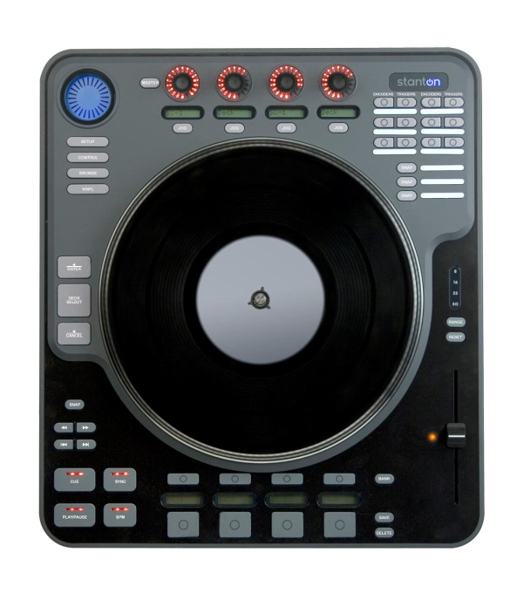](http://cdn.digitaldjtips.com/app/uploads/2010/12/09152859/stanton_scs_1d.jpg)The Stanton SCS-1d is distinctive in blues/greys, but maybe a bit \’lightweight\’.

#### Stanton SCS.1d

Price: [US$615](http://www.tkqlhce.com/click-3957275-10449560?url=http%3A%2F%2Fwww.guitarcenter.com%2FStanton-SCS-1d-Control-System-Deck-802028-i1396134.gc&cjsku=802028L) / [£398](http://www.thomann.de/index.html?partner_id=39004&page=gb/stanton_scs_1d.htm) / [€469](http://www.thomann.de/index.html?partner_id=39004&page=gb/stanton_scs_1d.htm)  
Rating: [rating=3]

Decks controllable: 2; High-resolution jogwheel: yes; Software compatibility: Traktor, Ableton Live; Size & weight: 3.3 x 14.5 x 16.8″ (84 x 368 x 427mm), 13.9lb (6.3kg)

They say: Compact controllers are great in some scenarios. But sometimes they’re just not enough. Tiny, non-motorized platters just don’t cut it when your goal is to try to emulate the vinyl experience. The SCS.1d is the perfect crossover device for DJs that want to embrace the advanced features modern software offers, while still staying rooted in a traditional workflow.

We say: This is a big unit, though lighter than you might think. The 10″ motorised vinyl and motorised pitch control (while the former feels a little lightweight for my liking) put it in a class of its own here, as do the velocity-sensitive trigger pads. If you’re looking for a controller that’s a straight replacement for a CD deck or vinyl deck, this may be it. It’s pricey, though.

See it at: [Guitar Center (USA)](http://www.tkqlhce.com/click-3957275-10449560?url=http%3A%2F%2Fwww.guitarcenter.com%2FStanton-SCS-1d-Control-System-Deck-802028-i1396134.gc&cjsku=802028L), [Thomann (UK & rest of Europe)](http://www.thomann.de/index.html?partner_id=39004&page=gb/stanton_scs_1d.htm)

[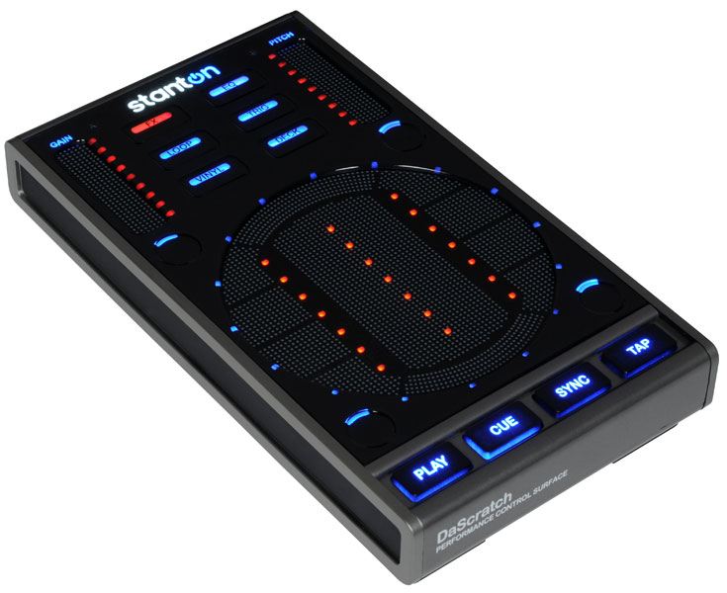](http://cdn.digitaldjtips.com/app/uploads/2010/12/09152859/scs3d.jpg)The Stanton SCS.3d is in the gun-metal finish, rubber and high-impact plastic and looks as futuristic as it is. It\’s also highly durable.

#### Stanton SCS.3d

Price: [US$153](http://www.amazon.com/gp/product/B001J1IODE?ie=UTF8&tag=pbmo-20&linkCode=as2&camp=1789&creative=390957&creativeASIN=B001J1IODE) / [£135](http://www.thomann.de/index.html?partner_id=39004&page=gb/stanton_scs_3d.htm) / [€160](http://www.thomann.de/index.html?partner_id=39004&page=gb/stanton_scs_3d.htm)  
Rating: [rating=5]

Decks controllable: 2; High-resolution jogwheel: yes; Software compatibility: Traktor, Ableton, Virtual DJ, PCDJ; Size & weight: 8.5 x 4.7 x 1.4″ (216 x 120 x 35mm), 1.1lb (0.5kg)

They say: SCS.3d’s compact and sleek profile makes it a space-friendly addition to any existing DJ gear set-up or it can stand on its own as a complete controller solution. Stanton’s StanTouch technology allows you to use traditional DJ-style motions and gestures on a touch-pad style surface.

We say: Small, highly durable, innovative, and just plain cool, we love the little SCS.3d. It’s everything that’s good about digital DJing. It’s taking the best of what analogue can do and giving it a twist that’s new.

See it at: [Amazon.com](http://www.amazon.com/gp/product/B001J1IODE?ie=UTF8&tag=pbmo-20&linkCode=as2&camp=1789&creative=390957&creativeASIN=B001J1IODE), [Thomann (UK & rest of Europe)](http://www.thomann.de/index.html?partner_id=39004&page=gb/stanton_scs_3d.htm)

### Conclusion

All of these controllers offer much to any of the DJ types mentioned in the introduction – there are no bad models here, hence they all get good scores. We’ve dished out the 3s, 4s and 5s depending on how well the controllers fit into our own ideals of innovation, portability and quality. For instance, if you want the best quality, Allen & Heath has it. Two of those alongside, say, their own Xone:DB4 mixer will give you one absolutely awesome DJ set-up.

But Denon’s new controller is also pro-grade, and alongside the more consumer-quality models from Reloop and DJ Tech offer a better range of features, including 2 and sometimes 4 deck control with the one unit through clever colour coding.

Stanton’s controllers couldn’t be more different from each other, with one actually trying to be extremely traditional (and maybe slightly the worse for it), but the other smashing through the barriers of what DJ equipment should look and feel like, and doing it brilliantly.

Find the one that suits what you want to do, and try and give it a go first (or make sure you can return it if it doesn’t feel right to you) – you will be using your controller intimately for many hours, so get it right at the start.

We hope this guide has been of some help in showing you how different manufacturers have approached the same basic issue. good luck!